Project Proposal

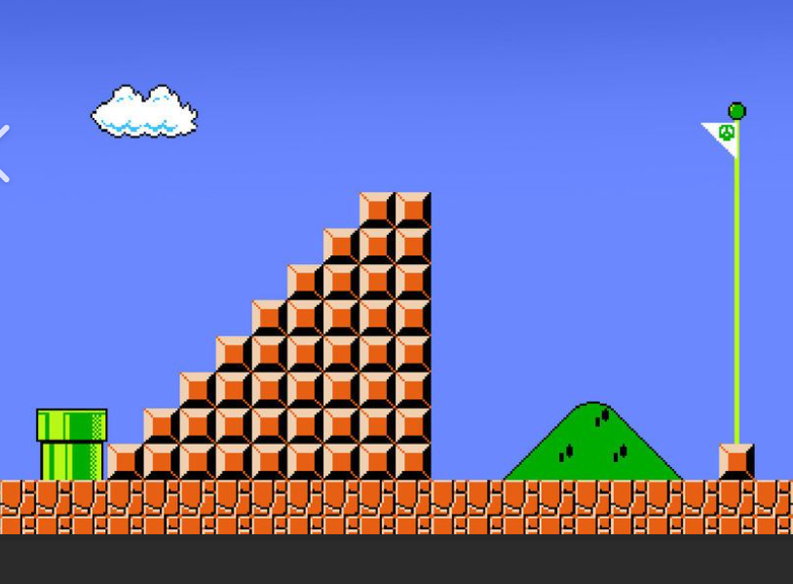
Source: Nintendo. (1985). Super Mario Bros. (N.E.S.). www.nintendo.com.

After long deliberation, I decided to simply go with a 2D image of Super Mario Bros. (Nintendo) because it consists of a dynamic range of 3D primitive shapes, and I found it to be a very interesting piece to potentially recreate. I will be creating most of these objects, including the pipe, staircase (and ground) blocks, flagpole, and hill, as well as a blue plane for the background. The clouds seem as though they would be quite tedious to create and would require a massive number of smaller primitives to form, so I have decided to omit this object. Although, I may end up including a cloud in the background texture.
I have decided to leave off the spherical flagpole top due to time restraints, so I will be using a total of four different types of 3D primitive shapes in the recreation of this image:
- cubes (staircase blocks and flagpole base block)
- planes (background, ground, and triangular flag)
- cylinders (pipe and flag pole)
- irregular pyramid (hill)
Recreating a 2D scene with this many shapes can easily become an overwhelming task using OpenGL in C++, so it’s important to actively manage the overall scope of the work. I have sketched the image using graph paper on a 20 x 20 region consisting of 10 x 10 quadrants with the origin centered at (0,0), or (0,0,0) if considering a 3D space:
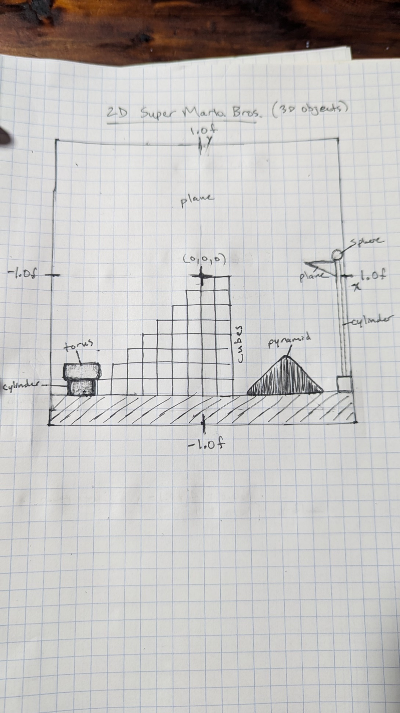
This made it a simple process of conceptualizing more quantitatively the components of the system and what 3D primitive shapes would be needed in the recreation process. Even more helpful is having a simple way of spatially organizing the elements of the image to be used when calculating the coordinates of different vertices when programming them into the software using C++. With these dimensions, a single graph square has the 2D dimensions $0.1f x 0.1f x 0.0f$, but a $z$-depth of $0.1f$ or $0.2f$ could be used for an added 3D effect. This will be convenient to know during development, although different sizes may be used in the final result.

